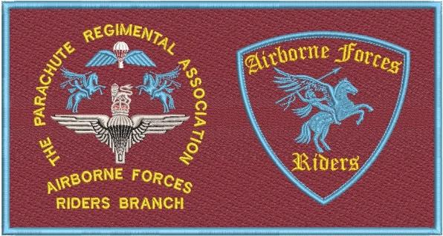
Appendix 4 to AFR Committee meeting 25 Apr 26
PRA AIRBORNE FORCES RIDERS – 2026 RIDE SCHEDULE

Dates | Ride | Lead | Ride | Comments
23 April | Arnhem Oak Project | Charlie McColgan | N | Details to follow
25 April | AGM - Cleethorpes | David Lang | N | Ride from Gainsborough TBC
24 May | Mick Willets | David Raes | N | Remembrance led by Newark PRA
6 June | SAMA Ride of Respect | Paul Moore/ Various | Y | Rides coordinated by regional reps under Paul Moore’s stewardship
19 - 21 June | Farmyard Rally | Paul Moore? | Y | Individuals to book. www.farmyardparty.com
27 June | Airborne Soldier Unveiling – Colchester | TBC | N | Look for a volunteer from SE to coordinate representation from AFR
18 July | Eden Camp | TBC | N | ABF Day North. Look for a volunteer from North England to coordinate representation from AFR
TBC | AFR Summer Rally | David Lang | Y | To be a choice from, or combination of:  Farmyard Rally Yorkshire  Normandy Battlefield Tour  Gathering coordinated by volunteer
25 July | PRA AGM at NMA | David Lang | N | Awareness only
27 August | Warren Point Remembrance | Vic Thorne | N | Awareness to support
6 September | Double Hills Memorial | George Firth/ Bob McK – Brown | Y | Always first Sunday of September.  Crosses at graves in Weston – S – Mare then ride to Paulton
12-13 September | Borough on the Hill/ Somerby | Dave Raes | Y | 10 PARA Remembrance.  Remembrance with FoTT
17-20 September | Arnhem | David Lang | Y
28 September | Cromwell Lock | Craig Gadd/ David Raes | N | Memorial Service for 131 Sqn RE
3 October | RTTW | David Lang | Y | 2025 will be Litmus Test to continue Whittington RV
December | Santa Rides | Phil Hannah/ David Lang | Y | Regional Events

