Appendix 2 to AFR Committee meeting 25 Apr 26

PARACHUTE REGIMENTAL ASSOCIATION –
AIRBORNE FORCES RIDERS BRANCH COMMITTEE AGENDA
25 April 2026, 1700 hours
Pegasus Bar, Cleethorpes
PRA membership
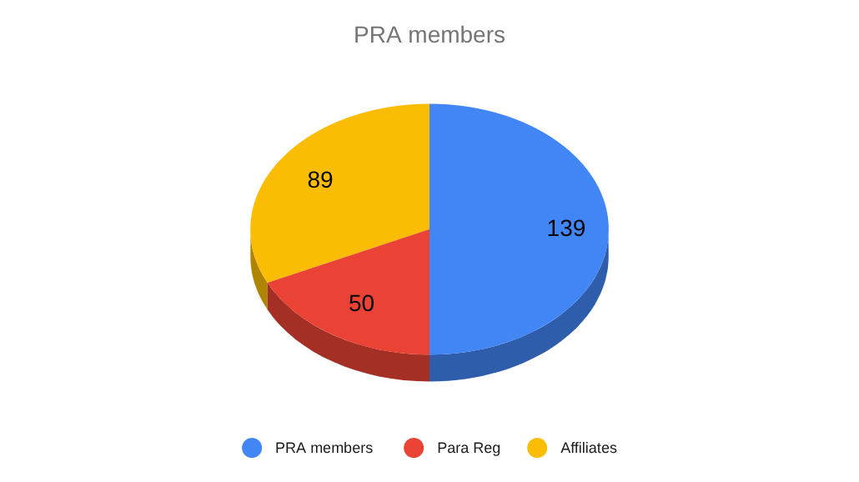

AFR membership
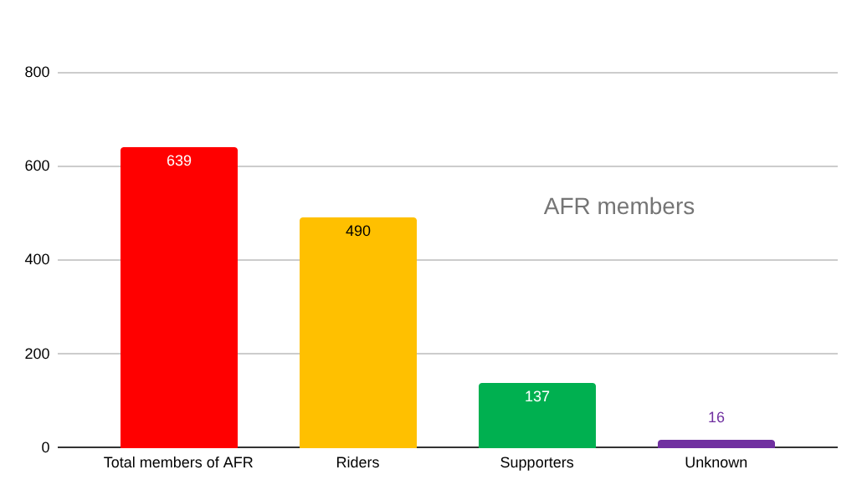
AFR Membership locations

