PARACHUTE REGIMENTAL ASSOCIATION –
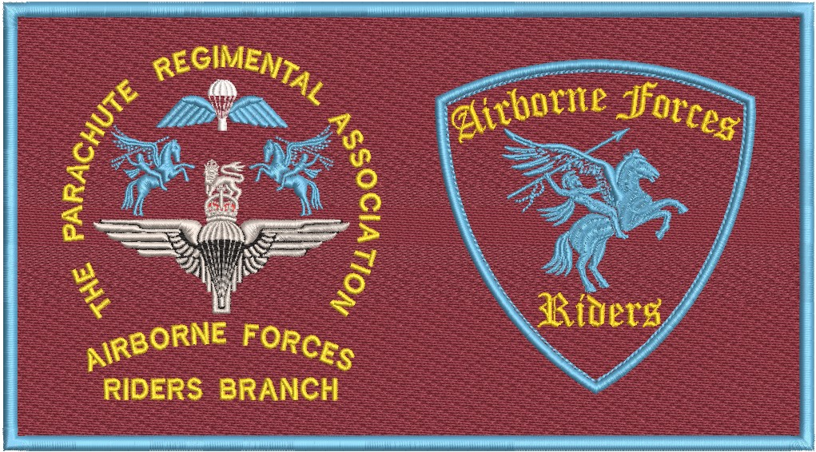
RIDERS BRANCH COMMITTEE AGENDA
25th April 2026, 1500 hours
Pegasus Bar, Cleethorpes
Attendees
Name | Appointment | Attending
David Lang | Chairman | Yes
Al Pearson | Secretary | Yes
Alex Brownhill | Treasurer | Yes
John Harratt | Deputy Treasurer | TBC
Paul Moore | Fund Raiser | Yes
Andy Rennison | Webmaster | Apologies
Barbara Bone  Steve Bone | Social Media  Social Media | Yes  Yes
Charlie McColgan | Welfare | Yes
Ron Webster | Standard Bearer | TBC

Agenda:
- Chairmans Opening Address David Lang

- Secretaries Update: Al Pearson
  - Previous minutes and actions
  - Membership
  - Other secretarial points

- Membership Rationalisation David Lang
a. Reminder of membership rules
b. 2 Years and PRA Membership (Supporters encouraged)
c. GDPR
d. Communication
- Welcome
- Subs
e. Revised status post rationalisation and removal of dormant members
f. Rules amendment – Honorary membership

- Treasurer’s Update: Alex Brownhill
  - Statement of Accounts
  - Other account matters

- Fundraising Update: Paul Moore

- Social Media Update:
  - Website Andy Rennison
  - Facebook Barbara Bone

- Welfare Charlie McColgan

- Standard Bearer Ron Webster

- Arnhem Accommodation David Lang

- 2026 Rides David Lang
a. Outline Rides, dates, leads and promotion
b. Summer Rally
c. Arnhem Saturday Ride and Titch’s ashes
c. Isle of Man 2027

- Funding Requests David Lang
a. Titch Cornish Funeral Costs - £698.49
b. AFR Pens (150) - £172.79
c. President authority to spend up to £300 for wreath and cross replenishment
d. Arnhem Oaks - uplift?
e. 11th Bn memorial bench
f. PRA – To be put to AGM

- Committee Changes David Lang
a. Publicity and Marketing
b. Equipment Manager
c. Appointment approach of next President/Chairman

- Regional Coordinators David Lang

- Invitation – Black Mafia RC David Lang
15. Behaviour and Disciplinary Process David Lang
15. AOB

