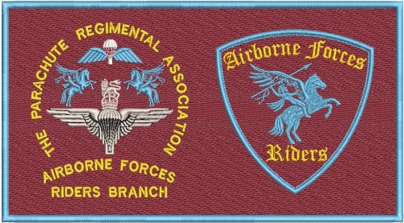
AGENDA ANNUAL GENERAL MEETING
PARACHUTE REGIMENTAL ASSOCIATION RIDERS BRANCH
26 1900 April 2026
Pegasus Bar Cleethorpes

- Opening Address Al Pearson

  - Welcome and thanks
  - Meeting protocols:
    - Agenda items only to be discussed
    - Voting – Paid members only.
      - Opportunity given to speak for a motion
      - Opportunity given to speak against a motion
      - Opportunity given to question a proposition
      - Proposer and seconder to be recorded

- Chairmans Annual Report David Lang

- Vote in Committee for 2026/27 David Lang

- Amendment of Riders Branch Rules David Lang
- Honorary Membership Proposal David Lang
- Secretaries Update: Al Pearson
  - Membership Reconciliation
  - Other secretarial points

- Treasurer’s Update
a. Statement of Accounts Alex Brownhill
b. Comments on spending David Lang

- Fundraising Paul Moore

- Social Media Update:
  - Website Andy Rennison
  - Facebook Barbara Bone

- Welfare Charlie McColgan

- 2026 Rides David Lang
a. Outline Rides, dates, leads and promotion
b. Black Mafia RC Invitation
c. Summer Rally
d. Arnhem – Scattering of Titch’s ashes

- 2027 Events David Lang
a. Isle of Man 2027
b. Melton Mowbray – 11th Bn Bench
c. Escort to Fallen Giants and Normandy battlefield Tour

- Regional Coordination David Lang

- PRA Matters David Lang
a. PARA App

b. Behavioural Standards and Disciplinary Process
c. Proposed Donation
- Roll of Honour and toast Charlie McColgan
- Close David Lang

