PARACHUTE REGIMENTAL ASSOCIATION (PRA)
Airborne Forces Riders Branch (AFRB)

Minutes of the Committee Meeting
held at:
Europarks Oostappen (Arnhem)
Thursday, 18th September 2025

Attendees

Name | Appointment | Attended
David Lang | Chairman | Yes
Al Pearson | Secretary | Yes
Alex Brownhill | Treasurer | Yes
John Harratt | Deputy Treasurer | Apologies
Paul Moore | Immediate Past President & Fund Raiser | Yes
Andy Rennison | Deputy Webmaster | Yes
Barbara Bone | Social Media | Apologies
Charlie McColgan | Welfare | Yes
Ron Webster | Standard Bearer | Apologies

AGENDA

Opening remarks - Apologies
Barbara Bone, Social Media sent apologies
Ron Webster, Standard Bearer sent apologies
John Harratt, Deputy Treasurer sent apologies

- Chairmans Opening Address
David Lang, Chairman, welcomed everyone to the meeting. He thanked them for their efforts during the year.

- Secretary’s Update
The secretary shared his report on the computer, showing detail of membership, PRA members and members by geographical area.
Secretary’s report can be found at Appendix A.

- Membership Rationalisation

- Reminder of rules. Chairman reminded the committee of the rules, namely that members should be a member of the PRA and pay subs of £10 per year, as voted on at the AGM in 2024. As per the secretary’s report it is clear we have too many non-committed members.
Decision: It was unanimously agreed that a rationalisation of AFR membership should be undertaken.

Action: Secretary and Chairman to draft an email to go out to all registered members, who are unpaid for 2025, requesting payment. 2 communications will be sent prior to the AGM in 2026.

- GDPR. It was agreed that we should not continue to hold personal information of legacy members. At the AGM in April a decision will be voted on with a view to deleting legacy members information.

- Communication. Communication will continue via three means, (social media, email from the secretary and the website)

- Treasurer’s Update

Treasurers statement of accounts can be found at Appendix B.

- Fundraising Update
Paul Moore advised the committee that we now have a Paypal set up for the AFR, he also informed the committee that he had commenced work on raffle prizes for the next AGM, as the previous AGM raffle was such a success.

- Social Media Update
- Website - The Webmaster explained how he had cleared the easy wins as he self learned the processes of webmaster.
The webmaster’s plan for the coming six months is to dive deeper into mastering the website and making it clearer for the members.
The Webmaster explained there were over 20 names hidden within the website that only password protected webmasters could use.
Decision: The committee voted unanimously to remove these names.
Action: The webmaster to remove the legacy hidden names.

- Facebook - No update available for the Facebook account other than the account owners continued their due diligence on people joining.

- Welfare
The welfare member explained he had been in touch with a Terry Goss who was a veteran Airborne biker and had been involved in a collision with a lorry in Wales. The welfare rep will continue communications with Terry on his recovery progress.

- Standard Bearer
The standard has been brought to Arnhem to be paraded at the Oosterbeek cemetery on Sun 21st Sep 25.
The standard will also be carried by Dave Raes at Cromwell Lock on 28th Sep to commemorate the 10 soldiers who lost their lives, from 300 troop 131 Independent Parachute Squadron Royal Engineers.
The chairman made specific reference and thanks to Michael Turnpenny (AKA Ziggy Milemuncher) for his dedication to the AFR and his manufacture of the standard.

- Arnhem Accommodation 2025 and beyond.
The chairman made reference to the standard of accommodation and facilities at the Europarcs Hooge Veluwe and that it would remain the recommended venue for the AFR in Arnhem.

- 2026 rides
A highlight table showing the 2026 planned rides and acts of remembrance can be found at appendix C.

- AFR pins
The chairman asked for support for the purchase of AFR pins to the sum of £350.40p.
Decision: The committee voted unanimously in favour.

- Committee changes
There are no planned AFR committee changes. The chairman agreed to confirm if Barbara wished to remain the Social Media Rep.
Post meeting Barbara confirmed she is happy to remain at present.

- Remembrance Bench Driel
The welfare member gave a brief on the financial success of the Flower Children of Arnhem pin sale. He explained the fund was in a good position and were looking at the manufacture and purchase of a bespoke bench to go at the Engineer memorial site in Driel.
Decision: The committee voted unanimously to vote over £50 to support an AFR emblem to go onto the bench.

- AOB

- Affiliation and cross comradeship with the Canadian Commando MC
An approach had been made by the Canadian Commando MC to form an affiliation with AFR. The chairman, having conducted some due diligence into the Motorcycle Club and was informed of association with Hells Angels and 1% activities. This is not in keeping with the spirit of the AFR so we will not support the affiliation.
Decision: The committee voted unanimously against.

- Do we support the British Army App
We had been approached by the secretary of the PRA on if we would support the building of a British Army App.
Decision: The committee voted unanimously in support of the app.

- Send AFR list to PRA
A request was made by the PRA secretary for a full list of AFR members.
Decision: It was decided this should wait until the membership reconciliation was complete (at AGM 2026), to enable us to provide an accurate submission.

- Support to memorial flowers
Annelieke Van de Leemput, organised a memorial for Pte Clarence Ash, a casualty of the Battle of Arnhem, in Schoonhoven. Despite being unemployed due to health, she personally paid for the flowers and for lunch for the AFR.
Decision: The committee unanimously voted over Euro 50 to buy a bouquet of flowers as thanks for her support and generosity to the AFR.

- Pte Clarence Ash
The AFR have been made aware of an Operation Market Garden fallen soldier, laid to rest in Schoonhoven, which is considerably further than our present ride of respect.
Decision: It was agreed that the committee will decide how to add this to the Ride of Respect in 2026 or add as a specific ride of remembrance.

- Younger riders
The chairman closed the meeting by asking for more ideas to try and get some younger riders into the branch.

Next Meeting: The next meeting is scheduled to take place in Cleethorpes PRA on 25 April 2026.

Appendix 1 – Summary of Decisions

Ref | Summary of Decisions | Decision Maker
18/09/25  D1 | It was unanimously agreed that a rationalisation of AFR membership should be undertaken. | Proposer: Chairman  Vote: Carried Unanimous
18/09/25  D2 | The committee voted unanimously to remove the names of members in the back end of the website. | Proposer: Webmaster  Vote: Carried Unanimous
18/09/25  D3 | The committee voted unanimously in favour of the purchase of AFR pins to the sum of £350.40p. | Proposer: Chairman  Vote: Carried Unanimous
18/09/25  D4 | The committee voted unanimously to vote over £50 to support an AFR emblem to go onto a remembrance bench at Driel memorial. | Proposer: Chairman  Vote: Carried Unanimous
18/09/25  D5 | The committee voted unanimously against affiliation and comradeship with the Canadian Commando MC | Proposer: Secretary  Vote: Carried Unanimous
18/09/25  D6 | The committee voted unanimously in support of the British Army App | Proposer: Secretary  Vote: Carried Unanimous
18/09/25  D7 | It was decided that a submission to the PRA with a list of members PRA numbers should wait until the membership reconciliation was complete (at AGM 2026), to enable us to provide an accurate submission. | Proposer: Chairman  Vote: Carried Unanimous
18/09/25  D8 | The committee unanimously voted over Euro 50 to buy a bouquet of flowers for Annelieke Van de Leemput as thanks for her support and generosity to the AFR. | Proposer: Chairman  Vote: Carried Unanimous
18/09/25  D9 | It was agreed that the committee will decide how to add a visit to the grave of Pte Ash to the Ride of Respect in 2026 or add as a specific ride of remembrance. | Proposer: Chairman  Vote: Carried Unanimous

Appendix 2 – Summary of Actions
Ref | Summary of Actions | Owner | Target Completion Date
18/09/25  A1 | Secretary and Chairman to draft an email to go out to all registered members, who are unpaid for 2025, requesting payment. Two communications will be sent prior to the AGM in 2026. | David Lang  Al Pearson | AGM 2026
18/09/25  A2 | The webmaster to remove the legacy hidden names | Andy Rennison | October 2025

Appendix A – Secretary Report:
PARACHUTE REGIMENTAL ASSOCIATION –
AIRBORNE FORCES RIDERS BRANCH COMMITTEE AGENDA
18 Sep 2025, 1500 hours
Europarcs, Arnhem
PRA membership
Non PRA members known - 530
PRA Members known - 124
Parachute Regiment - 49
Affiliate members - 75
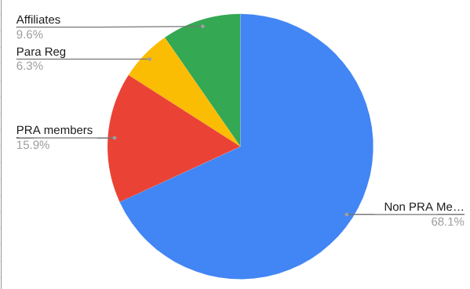

AFR membership

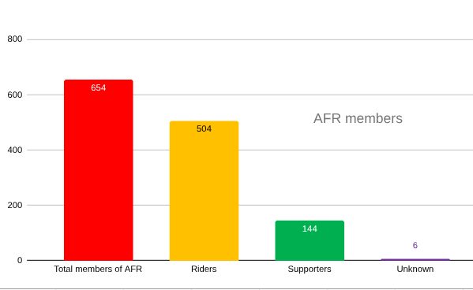

AFR Membership locations by Country
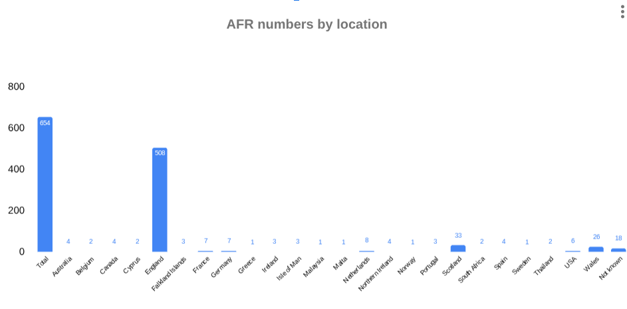

Appendix B – Treasurer report
Appendix C - AFR 2026 Rides and Remembrance
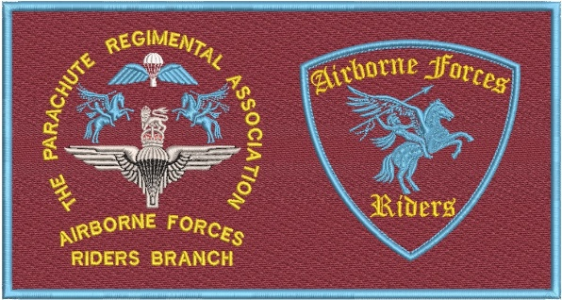
PRA AIRBORNE FORCES RIDERS – 2026 RIDE SCHEDULE

Dates | Ride | Lead | Ride | Comments
23 April | Arnhem Oak Project | Charlie McColgan | N | Details to follow
25 April | AGM - Cleethorpes | David Lang | N | Ride from Gainsborough TBC
24 May | Mick Willets | David Raes | N | Remembrance led by Newark PRA
6 June | SAMA Ride of Respect | Paul Moore/ Various | Y | Rides coordinated by regional reps under Paul Moore’s stewardship
19 - 21 June | Farmyard Rally | Paul Moore? | Y | Individuals to book. www.farmyardparty.com
27 June | Airborne Soldier Unveiling – Colchester | TBC | N | Look for a volunteer from SE to coordinate representation from AFR
18 July | Eden Camp | TBC | N | ABF Day North. Look for a volunteer from North England to coordinate representation from AFR
TBC | AFR Summer Rally | David Lang | Y | To be a choice from, or combination of:  Farmyard Rally Yorkshire  Normandy Battlefield Tour  Gathering coordinated by volunteer
25 July | PRA AGM at NMA | David Lang | N | Awareness only
27 August | Warren Point Remembrance | Vic Thorne | N | Awareness to support
6 September | Double Hills Memorial | George Firth/ Bob McK – Brown | Y | Always first Sunday of September.  Crosses at graves in Weston – S – Mare then ride to Paulton
12-13 September | Borough on the Hill/ Somerby | Dave Raes | Y | 10 PARA Remembrance.  Remembrance with FoTT
17-20 September | Arnhem | David Lang | Y
28 September | Cromwell Lock | Craig Gadd/ David Raes | N | Memorial Service for 131 Sqn RE
3 October | RTTW | David Lang | Y | 2025 will be Litmus Test to continue Whittington RV
December | Santa Rides | Phil Hannah/ David Lang | Y | Regional Events

