PARACHUTE REGIMENTAL ASSOCIATION –
AIRBORNE FORCES RIDERS BRANCH COMMITTEE AGENDA
26 April 2025, 1900 hours
Pegasus Bar, Cleethorpes
PRA membership
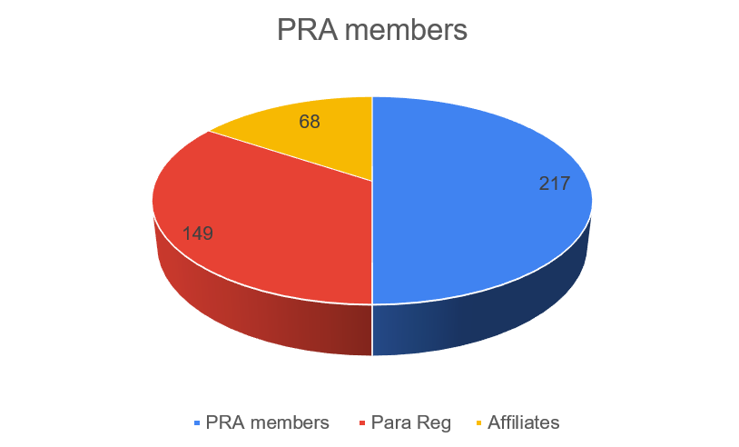
AFR membership
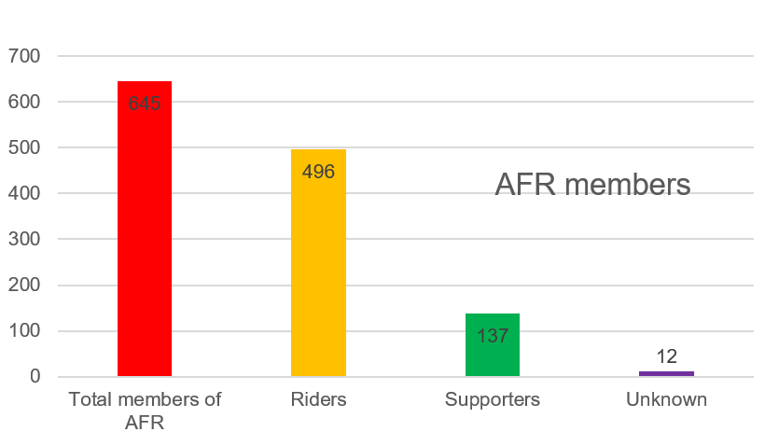

AFR Membership locations

